Unit 5 Project

DofE scheme planning application

Table of Contents

Discussion 3

Broad aims 3

Current system 3

Aims of new system 3

Potential limitations of new system 4

Investigation 5

Methods of investigation 5

Questionnaire 5

Document collection 6

Existing student interface 6

Research into existing solutions to similar problems 7

Involvement of stakeholders 8

Students 8

Teachers/Staff 8

Moderators 8

Data flow 9

Input data 9

Processing/output data 9

Data flow diagrams for current system 10

Limitations of current system 12

Specification 12

Summary of purpose of project 12

Methods 12

Objectives 13

Design 14

[Processes 14](https://d.docs.live.net/a185dec072f534a7/Python%20Programming/A-Level%20computing%20stuff/Computer%20Science%20Unit%205%20NEA%20Project%20Report.docx#_Toc60400337)

Overview of system – decomposition into sub-problems 14

Input and Output 15

General User interface 15

Student interface 16

Staff interface 19

Data structures 23

Entity relationship diagram (ERD) 23

Data sturcture tables (inc. validation) 23

Methods of data access 31

Algorithms/Processes 32

Hash user password 32

Validate/authenticate login 32

Generate section status 33

Shorten text 34

Calculate end date 34

Get weekday abreviation and date parts 35

Get upcoming events within timeframe 35

Enforcing password strength 35

Write activity summary 36

Tabulate output 36

Parse tabulated input 37

Write data to file 37

Read data from file 38

Evaluation 39

Appendix A – Documents 40

Document 1 Questionnaire 41

Document 2 Questionnaire response 42

Document 3 Enrolment Form 43

Document 4 Parental Consent Form 44

Appendix B – Screenshots 45

Screenshot 1 Current eDofE student home screen 45

Screenshot 2 eDofE section overview 45

Screenshot 3 Example of completed section information in eDofE 46

Screenshot 4 Example Google Calendar week view 46

Screenshot 5 Adding an event to Google Calendar 47

Screenshot 6 Student grade overview in Google Classroom 47

Appendix C – Diagram and notation keys 48

Data flow diagrams 48

# Discussion

For my project, I will be working on a solution to meet the current organisational needs of the teachers coordinating the DofE award and associated expeditions within my school. The award has been running in the school for many years but with larger groups of students, it can become difficult to keep track of individuals’ progress.

Arranging the scheme encompasses tasks ranging from coordinating which students are on which trips, to seeing the section progress of lots of students (~80/academic year) across multiple year groups, each within their separate award schemes (Bronze, Silver, Gold) and each encompassing four sections (volunteering, physical, skill and expedition). Due to the final award being externally moderated, the data organising process must be streamlined and transparent and data easily accessible where required.

For the students themselves, they also have a complicated job managing what sections of the award they still have left to complete and what evidence/material they still need to submit in order to achieve their award.

## Broad aims

### Current system

Currently, the teachers use a combination of a paper based (manually filed) and an online standardised system (eDofE) – this can lead to filing errors, with documents being misplaced, and makes it hard to quickly view overall student progress in overview. Getting new data/information (i.e. for new award levels, expeditions etc.) from students can also be time-intensive and this is often recorded via multiple multi-page paper forms which are easy to lose track of; not to mention that these can be very difficult to categorise and sort efficiently.

Students also need to remember long lists of tasks (including things like what equipment they need to pack, what their expedition dates are, etc.) and to actually fill out and return the forms handed to them. Currently, the system facilitates some of these requirements in terms of allowing students to provide details of the activities they are undertaking but others, like expedition planning in particular, are left for the student to organise by themselves with only some verbal guidance from staff.

#### Feedback considered

I conducted a brief presentation of an outline of my proposed user requirements (listed in Involvement of stakeholders), and my above perspective of the current system, to the current DofE staff team at school (via Skype). This involved discussing the different user groups in turn and examining an overview of how the current process operated. Later on, during the Investigation, I returned to these points in more detail on my own.

Their verbal feedback informed the aims below that my new system will try and address. They were also very helpful in pointing out some of its potential limitations, listed below; in particular, those related to the privacy aspects of the software and ensuring appropriate levels of access to restrict access to potentially sensitive student data.

### Aims of new system

My aim is to tie these two systems closer together so that, while keeping their roles distinctly separate (so that there is no duplication of functionality and data), they become more integrated with each other, making overall data overview and tracking easier for the staff involved. Providing students and staff with a way to quickly see what needs to be done in order to fulfil certain aspects of the award scheme is my main goal.

Overall, I aim to create an application, with a Tcl/Tk GUI (to enable intuitive use), that:

* Provides an account system with a separate interface for students compared to teachers, along with restricted levels of access to stored data
* Allows staff to manage and plan expeditions easily and more effectively than using assorted paper records
* Enables students to manage their progress through the award effectively and submit required information to their teachers on request
* Allows staff to view the progress of all or specific students within different aspects of the award
* Enables coordinated expedition planning between teachers (sharing trip information) and students (submitting/’ticking off’ the listed requirements while viewing the provided information)

### Potential limitations of new system

* Due to my planned usage of tkinter to create the GUI, interface will be quite basic and will focus on functionality over aesthetics. Due to the single-threaded nature of Tcl/Tk implementation, some longer processing operations will also cause the GUI to freeze and become unresponsive while python continues to work in the background.
* The system will not authenticate the credentials of moderators (as this would require additional linking to the external DofE database) so it will be up to the staff to ensure that this feature is not abused for malicious purposes to access potentially sensitive and personal data stored.
* Local data storage will not be designed to be secure due to time constraints. The software will *not* have its own encrypted file format so anyone could theoretically access the raw data within the database as well as any login details stored. This is an issue in terms of GDPR and other privacy laws (especially concerning student data) so access to the software’s source and database directories must be controlled separately.
* The data for the system will be stored locally within the database, so in order for a cross-machine/network-wide (i.e. multi-user) setup to function correctly, it would need to be stored/hosted remotely (on the school server for instance).
* The above could also introduce new file handling scenarios (such as multiple people trying to alter the same record within the database at the same time) which are outside the scope of this project. The software will not support these instances and will be limited to single machine interaction – imagining that all users access the software from a single shared machine.
* The system would not be able to act as a full substitute for paper records as physical copies of certain forms, such as those detailing parental consent, are needed for school records. Things like signatures to signify consent will also obviously not be able to be replaced by this new system.

# Investigation

## Methods of investigation

Due to the particular circumstances of COVID restrictions on the school grounds in terms of year-group bubbles, I was limited in the variety of methods of investigation I could do into the existing system. For example, direct observation of use of the current system was not possible. Added to this was the fact that the DofE scheme was this year running in a much more limited capacity with no out of school expeditions planned.

Nevertheless, I conducted all aspects of my investigation around the framework of the following prompts:

* How does the current system, as a combination of eDofE and paper records, operate?
* What data on students is needed (inputs), how is it collected and what parts are stored?
* What features/processing capabilities do the users need and what data needs to be output/displayed?
* How can information obtained be displayed in an easily over-viewable and accessible way? Additionally, what pieces of data are the most important to see quickly?
* What are the main issues with the current system?

These informed the Questionnaire’s structure, which parts of my Existing pupil interface I investigated more closely, specific aspects of Document collection and the areas of focus for my desk-based research.

### Questionnaire

Given the COVID restrictions in place, I decided to create a Google Form that I could email to the two main DofE management staff for them to complete digitally. This would allow me to collect the most important information on the current system with relative ease – having to act as a substitute for full detailed interviews. However, I would need to ensure that the questions were designed in such a way as to ensure that I collected sufficient and relevant data to build the new system.

The final questionnaire (Document 1­ attached in Appendix A – Documents) hence asks several questions as to the sort of data that is needed on each student and the process of organising expeditions. I also tried to get an idea for what the issues with the current system were and how it could be improved so as to ensure the best user experience for the staff who would use the new system.

#### Analysis of responses

Regrettably, only one member of the key staff had the time to get the questionnaire back to me (Document 2) but the basic data provided still proved useful in investigating the existing system. It now just means that I will place greater weight on the other sections of my investigation in terms of informing decisions throughout my project.

The response highlighted how important the current eDofE system was but also raised the fact that the software was not very intuitive (the respondent gave a 3/5 – with 5 being the easiest to use) and that it could be difficult to find information – these are then both clearly issues I need to address. Interestingly, the main stated reason for the continued use of paper records was for “ease of use of parents”. This made me consider parents as a prospective end user of the system. However, in the following question parents were not given as a potential user which suggested to me that a more useful potential feature may be to allow paper records to be printed off from the application to then be handed to parents – a kind of ‘student report’ – rather than adding parents as a fully-fledged user to the system.

Another very insightful question was identifying the 3 most important pieces of student data. (I had created this question in order for me to suitably design the overview section of the application.) These turned out to be the current award level, the progress per section and the student’s session attendance. The questionnaire revealed that, currently, the staff are also able to edit student data, send messages to students and export records.

### Document collection

Thanks to my past involvement with the scheme, I was able to obtain blank copies of the two main forms that I had to fill in while signing up for the scheme: Document 3 Enrolment Form and Document 4 Parental Consent Form. These step through the basic data that was needed from each student and will help inform the details of the Data flow below. They also helpfully categorise it into information concerning each student and then each separate expedition and the parental consent required.

#### Analysis of documents

##### Participant enrolment form – Document 3

This form splits the data required from the student into several key sections, making it easier for staff to glance at the form in overview and for the student to see what the different parts of data that they submit will actually be used for. These sections are:

* DofE Centre information – *centre ID and year group*
* Details on the DofE level – *level itself and whether the student is a new applicant*
* Personal details – *name, gender, date of birth, language and enrolment date*
* Contact details

The latter part of the form is then simply the declaration of consent. This analysis has suggested to me that I should organise the interface of my student forms in a similar fashion and perhaps arrange the tables within my database in a similar way. Additionally, I should make sure to include a button for the user to confirm that they are happy for their data to be stored within the system.

##### Parental consent form – Document 4

The first part of the form provides information to the student and parent about the details of the proposed activity – completed by the DofE staff beforehand – including the destination, activities and the date/time. The form is then split into separate headers for student information, emergency contact details, medical and any additional information. The risk assessment that follows has also been completed by the teacher in advance and exists as reference for the parent and student. Finally, the form closes with passages on data protection and conduct during the trip in addition to the actual declaration of consent.

### Existing student interface

Due to my participation in the award scheme previously, I was easily able to investigate what tools and the user interface design of the student-side of the system.

#### Home Page – Screenshot 1

The home page shows a number of key features including my progress through each of the sections of the award (volunteering, physical, skill and expedition) as a simple graphic. These dials only have three different positions – ‘not started’, ‘in progress’ and ‘completed’. On the right sidebar, there is a small tab to access messages send to be by leaders/staff while on the left is a quick overview of my personal information (which I then have the option to edit) as well as menus to access and fill in the various stages of my award.

#### Award details – Screenshot 2

This page allows the user to input details concerning each stage of their award. Shown in the screenshot is a completed skills section. The key data fields [data types given in square brackets] are the timescale [integer] (this is from a choice of 3 or 6 months with a compulsory distribution changing based on award level: Bronze 3, 3, 6; Silver 3, 6, 6 volunteering; Gold 6, 12, 12 volunteering) the start date [date], the type of activity [string], detail of activity (inc. location) [string], goals [string], assessor’s name and position [string], assessor’s email [string-format] and their phone number [string-format]. The student then has the option to save this information as a draft or submit it to staff for review and approval. Once they have completed the activity, the student is able to upload evidence (e.g. photos and assessor’s reports) from the same page. Once this is done, they can finally submit the section for final moderation. On the same page, the student can also view any comments that staff have left on their section details. ­­­

#### Section Progress – Screenshot 3

This page provides a very useful overview for students of their current progress through each of the four sections of a particular award (with options on the sidebar to view historic progress through previous levels). It provides a graphic of completion status once again (as on the home page) alongside other important overview information, mainly concerning dates of completion and details about the type and arrangements of the activity the student has chosen to carry out.

### Research into existing solutions to similar problems

Since the system presents an example of a relatively standard data storage and planning tool, desk-based research into existing planning and student moderation applications will be quite useful as it will allow me to see what is common to these systems and the most important functions that are often added to work with data. Alongside any observations I made in this section, I considered how I could implement what I had learnt into my final design.

#### Planning applications

I decided to look at *Google Calendar* as an example of a general-purpose planning application in order to gain an understanding for what information the user entered as well as how this was then displayed. Even though a full-blown calendar interface will not be required (since the application I am creating will not be as ‘event-dense’), I will be able to use the knowledge gained from this research to appropriately design and layout my interface for students and staff when it comes to organising lessons and expedition dates.

The main page of the calendar (Screenshot 4) displays what events are scheduled and for what times. Different event types are colour coded – I could adopt a similar styling to differentiate between group sessions, final expeditions and kit checks etc. Times are clearly displayed under each date with a small superscript for the day of the week – again, I could make sure to add a function that adds the weekday onto any dates displayed for added clarity to the user.

When planning an event (Screenshot 5), the user can enter a title as well as dates and times. The software also offers an option to add specific ‘guests’ to an event as well as set timed reminders and a description. I might consider replicating a ‘guest’ feature in the application by allowing staff to add specific students, from a set list restricted based on the award level, to meetings and organisation in order for these to come up on a specific ‘events’ list for students – potentially even on their homepage in a ‘key dates’ box. Linked to this could also be a reminders/alerts system for students based on key dates entered by teachers.

#### Academic marking applications

Our school currently uses *Google Classroom* to coordinate assigning work to students and measuring performance etc. The software has many features which are not applicable to this application but it does have a ‘Grades’ tab (Screenshot 6) which displays a summary of student performance for teachers to easily overview. It allocates a row to each student (which can be sorted by first or last name) and then uses columns for each task the student has undertaken and they grade they received. Every assignment has a date superscript, a class average and then the status of each student (which ranges from ‘Turned in’ to ‘Missing’). This table/spreadsheet-like layout is a common standard across these sorts of applications so is likely what I, too, shall be using for my staff overview page where each student’s progress in the award can be referenced.

I could also seek to replicate the way work is assigned to students in the application with teachers currently being given the option to assign students class material, homework or a quiz. I could do something similar by presenting teachers with various options as to the degree of urgency of the dates/tasks they give to students.

## Involvement of stakeholders

Informed by my initial discussions, as well as my research into the existing system (and those similar to it), I am now able to produce the following list of stakeholders in the current system and their requirements of the new system.

### Students

The staff DofE team need a system that can: ## doublecheck these actually fit into this section

* Provide a basic interface to students, which is appropriate in functionality (i.e. limited in the extent of data access compared to the teacher dashboard)
* Have separate accounts for individual students to allow them to manage their own data relating to the award
* Display to a student their current progress within their current award along with relevant details such as dates of expeditions and practices
* Prompt a student to complete the necessary forms and provide the required data (including uploading assessor’s reports and evidence for their various sections) in order to go on expeditions and complete the award
* Allow students to prepare for an expedition by uploading their route map, referencing an equipment list, etc. and allowing the student to work through these with a todo list

### Teachers/Staff

The staff DofE team need a system that:

* Has restricted levels of access in order to limit access to sensitive student data to only certain individuals
* Can ‘push’ the details of an expedition (including equipment, a route map, dates etc.) to student’s accounts so that they can view details on their next login
* Allows them to view the details (level, age, etc.) and progress (in the activities within each section) of students currently undertaking the award – ideally in an easily overview-able form (e.g. in a summary table)
* Has the option to save and print off PDF copies of specific records/group info for hard-copy reference

### Moderators

The staff DofE team need a system that can: ## make sure on one page as next bit

* Output the data required by the moderator in an easily sharable and overview-able format
* Filter/search the data in the teacher dashboard so that only specific requested data is visible
* Save the data requested to a file and load previously saved/backed up data from a pre-existing file

## Data flow

### Input data

The following list of input/stored data is a culmination of this investigation (answering my second initial prompt at the beginning of this process) and will serve as a highly useful reference point during the Design section in terms of the data structures I create.

#### Per Student

|  |  |
| --- | --- |
| * User ID | * Address |
| * DofE Centre ID | * Phone and email contact |
| * Year Group | * Emergency contact details |
| * DofE Level (one of three) | * Primary language |
| * Full Name | * Enrolment date |
| * Gender | * Fee/payment received? |
| * Date of Birth |  |

#### Per award section (per student) (volunteering, physical, skill)

|  |  |
| --- | --- |
| * Start date | * Goals |
| * Length (selection limited by level) | * Assessor’s full name |
| * Current progress (dynamic – depends on other fields) | * Assessor’s phone and email contact |
| * Type of activity | * Activity evidence/assessor’s report |
| * Activity details |  |

#### Per expedition/event

|  |  |
| --- | --- |
| * Start date | * Equipment list |
| * Event length | * Route map (path to image) |
| * Students involved (linked to student DB) | * Main activities |
| * Location/destination | * Risk assessment/Hazards (list) |

### Processing/output data

Based on the information I gathered through my questionnaire, analysis of the student interface and by investigating similar systems above, I have been able to compile this outline of the processes carried out by the existing system together with the outputs these need to produce:

* Allow staff to edit student submitted data
* Allow staff to send messages to students
* Export PDFs/physical copies of student data for permanent physical records
* Export digital copies of student tables for later retrieval/backup
* Allow students to upload evidence for each section
* Visualise of a student’s progress through an award section
* Produce an overview of all participants in an award’s progress

### Data flow diagrams for current system

Data flow diagrams can be used to show the main processes within the current system and how data moves into, out of and between different areas/aspects of the system. A key of symbols used is shown in Appendix C – Diagram and notation keys.

#### Registering a new student

Participant enrolment form (signature)

Participant enrolment form

Register student with eDofE

School student physical record

Retrieve paper records

School DofE Staff

New student

New student’s parent

Student eDofE record

#### Setting up a student ‘profile’/detail

Login to eDofE site

Fill in details for all 3 award sections

Student eDofE record

Records updated

Registered student

Fill in personal details digitally

Student eDofE activities record

Records updated

Select each award section

#### Preparing for an expedition (on an award level basis)

Propose new expedition date and details and distribute forms

Update school calendar and paper records

Verbal announcement to students

Expedition records

Parental consent form

School student physical record

School DofE Staff

Parents of students enrolled in award level

Student enrolled in award level

Confirm participation, plan route and submit equipment list

Digital scans of map

Source equipment and mark up map

Parental consent form

#### Completing a level of the award

Verify assessor’s report and section as whole

Student eDofE record

Records updated

Student enrolled in award level

Upload assessor’s report and mark complete

Student eDofE activities record

If valid, section marked completed

Staff alerted to change

Login to eDofE site + navigate to an award section

Verify that all 4 required sections completed  
(volunteering, physical, skill and expedition)

School student physical record

Checks from external moderators and certificate printed

School DofE Staff

## Limitations of current system

I have identified several weaknesses in the current system that are obviously then key aims for me to address during the development of the new system.

*Please note that because of the inability to observe the use of the current system due to COVID and the fact that the scheme is running in limited capacity this year for the same reason, some of the issues discussed here are potential/hypothetical issues rather than concretely observed ones.*

* The online system (eDofE) can be difficult to use and unintuitive at times which could lead to frustration and increasing the time it takes for minor tasks. This is due to a variety of factors including interface layout with many submenus and the way data is grouped which can result in information being difficult to find (raised in Questionnaire response).
* The current system is spread across both digital and paper records meaning organising what needs to be collected from students can be confusing. Additionally, it can make it hard for the students themselves to know where they need to be submitting information (I’ve experienced this myself during the scheme). Sometimes the school requires a physical consent form, other times they need the information entered on eDofE.
* The paper forms themselves are an issue too as they will often end up being submitted digitally anyway, making the paper copy redundant. Time is hence wasted re-entering data (in the case of students) or manually copying up data into the digital system (for staff registering new students).
* Data duplication is also an issue with several paper forms requesting the same data (e.g. contact details). This could potentially lead to clashes within the main digital database due to any conflicting information submitted (e.g. students accidentally completing two copies of the same form).
* Other additional information, such as equipment lists and expedition routes are spread across various different resources from the official DofE website to a folder in the school shared drive. Staff must therefore direct students to different places each time for various tasks which just adds unnecessary confusion.

## Specification

### Summary of purpose of project

I aim to create an intuitive and reliable computerised system for managing the DofE scheme at Rougemont, eliminating the need for the paper aspect of the current system. The system will utilise various levels of access (with a login system) and store data on students’ respective progress through various stages of the award in a relational database. Staff will be provided an overview of stored student data as well as the ability to search through this data and inspect it more closely.

### Methods

Due to my familiarity with the language and thanks to the abundance of additional useful libraries it provides (even with the default installation), I will be using Python 3 to program my system. This will also allow me to easily modularise different parts of my project into different files, reducing the line count of individual files significantly improving my potential overview of the program as a whole. The libraries that I am likely to be using include Tkinter (Python’s Tcl/Tk GUI creation implementation), datetime (for handling dates and related time information) and the ReportLab library (for producing PDF printouts of program data).

### Objectives

I have decided to use the SMART framework for my criteria (Specific, Measurable, Achievable, Relevant and Time-bound) in order to ensure that the objectives I create are suitable for the task and provide a clear goal for my project. The required/measurable performance of the system (in terms of speed, usability, etc.) is highlighted in **bold**.

#### Success criteria

By the end of my project I should have produced an application for the staff running the DofE scheme that:

* Has an intuitive interface with a clear layout – a new user (student or staff) should be able to find the information they need with **no guidance** other than within the application
* Allows students to enrol in the DofE scheme
* Allows the same student to go on to further levels of the scheme after completing one
* Allows students (and authorised staff) to edit data after initial submission
* Enables students to plan the required sections of their award
* Allows students to submit an assessor’s report once their section is complete and for staff to then moderate this submission
* **Only** shows a student’s **own data** to them, not any others students’ – to be accomplished via a login system and tiers of authorisation
* Allows staff to track **all** students’ progress through their respective levels of the award and see what is in need of moderation
* Offers a facility to search and sort student records by name, progress, etc. (by at least **5 different variables**) – a search should not take longer than **3 seconds**
* Provides staff with the facility to export PDFs of records for printing, moderation, physical backup, etc.
* Allows staff to plan expeditions in advance and share information easily (defined as **less than 3 actions**) with students
* Gives staff the option to quickly (defined as less than **5 minutes**) make equipment lists and upload route information to the program
* Shows students the dates and relevant information (defined as any events within the **next 7 days**), including route maps and equipment lists, for any upcoming important meeting and/or expeditions
* Ensures **all** data is saved when the user closes the program and allows this data to be loaded (both in less than **3 seconds**) when the program is started again
* Saves the above-mentioned data in a format that can be easily exported for moderation and re-import into a program on a different computer system

# Design

## Overview of system – decomposition into sub-problems

Student Login

### Processes

|  |  |
| --- | --- |
| 1. Welcome Screen/Login: Users choose login type then use unique username and password combination | 1. Student overview table: Staff are provided with a comprehensive overview of students’ progress through the award |
| 1. Award Overview: Students can see a home-screen with a summary of outstanding tasks/documents and key dates | 1. **Manage students**: Staff can create new logins for students and then approve the info they submit. The existing student database can be searched and viewed. |
| 1. Sign up/register: Students register for scheme and input details |
| 1. Per section info: Students can view info for each section and add appropriate evidence after filling in all required details | 1. **Plan Events**: Staff fill in details about upcoming events/expedition for it to then be ‘pushed’ to students/groups of students (by level) |
| 1. Calendar: Students can see upcoming dates (up to a week in advance) | 1. **Data management**: Stored student data can be exported as a file, for the program to load back into memory at a later date, or PDF |
| 1. Expedition preparation: After being ‘pushed’ by staff, students can prepare for an expedition and digitally give required details | 1. **Application close/exit**: The program’s database/memory is saved to a file at this time to be restored on next start-up |

Staff Login

View/edit section info

Upload evidence/report

Sign up/register

Allocate section timings

Calendar

Expedition prep.

Equipment tick list

View route map

View upcoming events and DofE sessions

Input form data

Edit personal details

Award overview

Per section info

Give consent

Create+Approve new registration

View student personal data

View student progress

Equipment list

Route map upload

Manage students

Plan Events

Data management

Welcome Screen

Search/filt-er students

Select/filter students

Print to PDF

Backup/export to file

Import from file

Mark attendance

Student overview table

Application close

Remove students

Manage events

Expedition

Breaking down the problem into subproblems using my Objectives (as above – decomposition), has provided me with a much better overview of the project as a whole and will allow me to modularise its different parts more easily. I will be able to focus on each named process (and its sub-processes) in turn and then combine them to create the final solution. This will also have the benefit of making bugs easier to locate and allow for more code reuse.

## Input and Output

### General User interface

In order to standardise the look and feel of the user interface including all form input/output, I will be using the following set of design guidelines for all menus, windows, etc. alongside tkinter’s ttk theme library which will automatically style windows according to the OS:

|  |  |  |  |
| --- | --- | --- | --- |
| Background colour: White (#FFFFFF) | Body text colour: Black (#000000) | Font: **Arial Bold**/Regular | Font sizes: 20/12 |

#### Welcome and Login

I will create a separate basic CLI application for the system’s admins to run in order to create staff logins in the database.



Due to their similarity, I might use the same GUI function here just with different text variables and methods assigned to the buttons, etc.

Each password will have a small view icon for the user to click *and hold* to view their entered password in plaintext.

No plaintext passwords will be stored anywhere – all passwords will be hashed and a salt added. This will ensure the login system is secure.

### Student interface

#### Award Overview

Linked from ‘*Login*’ button in **student login** Welcome and Login window



This will only appear as a particular level if the student has filled in and completed the relevant details. Otherwise, there will be a ‘Complete Registration’ button to click.

Should the student not have completed the required details above, or has already started, these buttons will be greyed out.



Sections can be “Not Started”, “In Progress”, “Needs Report” or “Completed”

These buttons relating to expedition preparations are only available if a teacher has ‘pushed’ an expedition to the student.

Students (who will have fewer events than staff in general) are shown their next 3 key dates in a listed view. They can choose to view more detail by clicking the button.



#### Sign up/Register

Linked from ‘*Complete Registration*’ button in Award Overview window



These dropdowns exist for fields which have a limited set of options. e.g. Gender: Male/Female/Other/Prefer not to say

Submits completed form to teacher (after confirmation and presence checks) for final approval before the student can begin using the system fully.

This date entry field will be validated to ensure that an appropriate (exists and in the past) date is entered.



#### Per Section Info

Linked from each section’s ‘*Edit*’ button in Award Overview window



This button will open a file section dialogue box allowing the user to select remote files to then be saved in the application directory (an ‘upload’ essentially).

Depending on the level of the award and the timescales chosen for the other sections of the award, some options here will be greyed out.

Calculated from the start date (check in future) & timescale selected above.



#### Calendar

Linked from ‘*View All*’ button in Award Overview window



Different categories of events (determined by teacher who created event) will be displayed in different colours – key events will thus be highlighted to students.

Students shouldn’t have as many events as staff so a simple list view will suffice. If there are no events in the next week, the interface will simply say ‘No events’. Each event consists of a weekday (generated from the date), a full date and the event’s name.

On hover of an event, a tooltip will show with ‘Click to view more details’. Clicking will then open a separate message box with further information about the event that was provided by the teacher.



#### Expedition prep

Linked from ‘*Route*’, ‘*Equipment’* and ‘*Details*’ buttons in Award Overview window respectively



Students can tick off the equipment they already have with each item they tick filling the progress bar.

The risk assessment is displayed as a bullet point list.

To confirm the user’s intentions, this button will first prompt a confirmation dialogue. box.



### Staff interface

#### Student Overview Table

Linked from ‘*Login*’ button in **staff login** Welcome and Login window



The user can click a student’s name to approve their enrolment, see more details, edit or remove them from the database.

This table uses these acronyms (for ‘In Progress’, ‘Completed’, ‘Needs Report’ and ‘Not Started’) in order to make it more compact – these could also be colour coded. The user can view key for these acronyms at any time by hovering over the letters.



The table also displays the timescales the student has selected (where available) in brackets.

The search bar at the top of the table can be used to the filter the list of students displayed by name. Student’s names will be checked for the substring entered. The teacher always views students by level selected in the dropdown.

~~The attendance column will contain a number of 4 different types of messages: “100%”, “N/A” (­–), “Missed # events” (up to 3) and “Missed ‘name of ev…’ ” (if only one missed in last 3).~~ *Dropped – outside scope*

Similar to student’s calendars with the list view of events within the next week or so. More details are then available to view via the ‘Manage Events’ button.

#### Manage Students

Accessed for each individual student by clicking their name in the Student Overview Table window (window opened dependent on status of student) or by clicking ‘*New Student*’



On hover displays further information about login detail requirements (left box) – i.e. password.



*Pre-‘pending enrolment’* – i.e. before the student starts filling out details themselves.

*Needs approval*

*In progress*

Opens a confirmation dialogue to verify member of staff’s intentions.



Allows staff to view progress and evidence that has been uploaded so far. The button to view evidence will only appear if a section has been completed and will open the folder where the student has had their evidence uploaded to by the program.



The login username submitted for the new student needs to be unique – the action will fail otherwise. A strong password will also be enforced. This could be done with a regex filter.

*Award details (accessed above)*

Next to each section the full current status will be displayed along with an abbreviated summary of the activity details submitted by the student.

#### Manage Events and Expeditions

Linked from ‘*Manage events’* button in the Student Overview Table window



Event ‘cards’ follow the pattern Title, Time with a colour coding based on event type.

‘View All’ present a scrollable list view of all events – this is meant less as an overview and more for reference.



The lower fields are inactive until a category is selected. Determines colour, listing info, etc.



For end: length is added to the datetime

*and time*

#### Data Management

Linked from ‘*Import/Export data*’ button in the Student Overview Table window



Button displays a warning before import file selection that this will overwrite all data stored – it will **not** merge data, just replace the current tables with the imported ones.

The export button creates a JSON file with **all** data from **all** tables currently stored within the application. These import and export buttons will **not** take into consideration selected checkboxes (due to the complex linking of tables) – a tooltip will inform the user of this.



The staff can select to export to the PDF only certain students by ticking each individual checkbox next to the students’ names or select all students by using the checkbox at the top of the table.

##### PDF Export

An example of the report (A4 landscape) generated by using the ‘*Export as PDF*’ functionality in the Data Management window



Each individual row/student has two ‘sub-rows’ in this Primary contact column with each bullet pointed:  
the primary phone number; the primary email address.

The report includes in its header a few useful bits of information to aid record keeping including: the date and time that the report was generated; the username of the staff member logged in when the data was exported; and the number of rows/students selected for export out of the total number.

The outputted PDF export includes a few additional columns not shown in the Data Management window that are independent of the staff anyway so cannot be changed and are merely included here for reference.

## Data structures

### Entity relationship diagram (ERD)

**STUDENT** TABLE

**SECTION_PROGRESS** TABLE

**STAFF** TABLE

**EVENT** TABLE

**STUDENT_EVENT** TABLE

The ERD shown here is already in third normal form with no transitive dependencies between any fields.

Username and password validation is carried out separately from main table access (dashed box) hence the login tables are separated from the main student/staff tables.  
i.e. username password checked 🡪 corresponding User ID returned

**STUDENT_LOGIN** TABLE

**STAFF_LOGIN** TABLE

**RESOURCE** TABLE

### Data sturcture tables (inc. validation)

*Any primary key fields are assumed to be unique (since they are always handled and generated by the program not the user).  
All fields include presence checks in their validation unless stated otherwise.*

#### Student login table

|  |  |  |  |  |  |  |  |
| --- | --- | --- | --- | --- | --- | --- | --- |
| Field Name | Key type | Description | Data type | Length | Example | Validation | Validation details |
| username | Primary Key | A user’s username – unique to each student | string | 2-30 | lucahuelle20 | length | username needs to be at least 2 characters long but no longer than 30 |
| password_hash | - | A salt + hash of the user’s password | string | 192 (salt 64) | 3953…e60e (shortened) | - | Generated within program |
| user_id | Foreign Key | The student_id of the username /password combination | integer | - | 5 | - | Generated within program linking to student table immediately |

#### Student table

|  |  |  |  |  |  |  |  |
| --- | --- | --- | --- | --- | --- | --- | --- |
| Field Name | Key type | Description | Data type | Length | Example | Validation | Validation details |
| student_id | Primary Key | Uniquely identifies a student | integer | - | 5 | - | Generated within program |
| fullname | - | Student’s full name | string | 2-30 | Luca Huelle | length | A student’s name should be a reasonable length (between 2 and 30 characters, including spaces) |
| centre_id | - | DofE centre ID of student | integer | - | 68362 | - |  |
| year_group | - | Student’s year group | integer | - | 12 | range | Must be between 7-13 (inclusive) |
| award_level | - | The level of award the student is taking part in | string | 4-6 | bronze | lookup | Must be one of bronze, silver or gold |
| gender | - | Gender that the student identifies as | string | 4-6 | other | lookup | Must be one of male, female, other, pnts (prefer not to say) |
| date_of_birth | - | Student’s date of birth | date | - | 23/10/2002 | range | Must be at least 10 years in the past but no more than 25 (age limit for DofE) |
| address | - | Student’s home address | string | 5-100 | 26 Dorallt Close, Henllys, NP45 3HW | - |  |
| phone_primary | - | Student’s main contact phone number | string (due to leading 0) | 9-11 | 07428 124796 | length | A valid personal UK phone number (including leading 0) is always between 9 and 11 digits. |
| email_primary | - | Student’s main email | string | 5-40 | example@ domain.com | format | Validating an email rigorously is extremely complex. This program will perform only a basic check for the format ‘ ?? @ ?? . ?? ’ |
| phone_emergency | - | The student’s preferred emergency phone contact | string (due to leading 0) | 9-11 | 07431 184796 | length | A valid personal UK phone number (including leading 0) is always between 9 and 11 digits |
| primary_lang | - | The student’s primary language (for reference and to determine language of any correspondence) | string | 5-7 | english | lookup | Must be either english or welsh |
| enrolment_date | - | The date that the student was successfully enrolled in the DofE scheme | date | - | 30/11/2020 | - | Generated within program when record is initially created |
| skill_info_id | Foreign Key | student_section_id for the student’s skill section | integer | - | 5 | - | Generated within program. Can be None also if section not yet started |
| phys_info_id | Foreign Key | student_section_id for the student’s physical section | integer | - | 6 | - | Generated within program. Can be None also if section not yet started |
| vol_info_id | Foreign Key | student_section_id for the student’s volunteering section | integer | - | 7 | - | Generated within program. Can be None also if section not yet started |

#### Section progress table

|  |  |  |  |  |  |  |  |
| --- | --- | --- | --- | --- | --- | --- | --- |
| Field Name | Key type | Description | Data type | Length | Example | Validation | Validation details |
| student_section_id | Primary Key | Uniquely identifies each entry of section information | integer | - | 5 | - | Generated within program |
| section_type | - | Determines the section type | string | 3-5 | phys | lookup | Must be one of skill, phys or vol |
| activity_start_date | - | Specifies the date that the activity is planned to start | date | - | 10/02/2021 | range | Must be in the future |
| activity_length | - | Dictates how long the student plans to do the activity for | time | - | 180 days | lookup | Must be one of 90, 180 or 360 days (3/6/12 months) |
| activity_type | - | A short name for activity | string | 3-20 | animal shelter | length | This should just be a short name to identify the activity by |
| activity_details | - | Extended text providing description of activity | string | 10-200 | I will volunteer at my local animal shelter and look... | length | The description should be between 10 and 200 characters in length |
| activity_goals | - | A brief text detailing the student’s goals for the section | string | 10-100 | I will gain skills in working with small animals. | length | The goal paragraph should be between 10 and 100 characters in length |
| assessor_fullname | - | The student’s selected assessor for this section’s full name | string | 2-30 | John Smitherton | length | An assessor’s name should be a reasonable length (between 2 and 30 characters, including spaces) |
| assessor_phone | - | The assessor’s preferred phone contact | string (due to leading 0) | 9-11 | 08431 184396 | length | A valid personal UK phone number (including leading 0) is always between 9 and 11 digits |
| assessor_email | - | Assessor’s main email contact | string | 5-40 | example. email@ domain.com | format | Validating an email rigorously is extremely complex. This program will perform only a basic check for the format ‘ ?? @ ?? . ?? ’ |

#### Student event table

|  |  |  |  |  |  |  |  |
| --- | --- | --- | --- | --- | --- | --- | --- |
| Field Name | Key type | Description | Data type | Length | Example | Validation | Validation details |
| student_event_id | Primary Key | Uniquely identifies each user-event pairing. Used for no other purpose | integer | - | 4 | - | Generated within program |
| student_id | Foreign Key | Identifies a student in the student table | integer | - | 5 | - | Generated within program |
| event_id | Foreign Key | Identifies an event in the event table | integer | - | 12 | - | Generated within program |

#### Event table

|  |  |  |  |  |  |  |  |
| --- | --- | --- | --- | --- | --- | --- | --- |
| Field Name | Key type | Description | Data type | Length | Example | Validation | Validation details |
| event_id | Primary Key | Uniquely identifies each event | integer | - | 17 | - | Generated within program |
| event_type | - | Refers to the type of event selected by the teacher | string | 9-24 | Group meeting | lookup | Must be one of ‘Group meeting’, ‘Kit check’, ‘Practice walk’ or ‘Assessed walk-expedition’ |
| event_name | - | The name of the event displayed to students and staff | string | 3-50 | Bronze practice kit check | length | This title should not be too long as it should summarise the event |
| event_start_date | - | The date *and time* of the start of an event | datetime | - | 16:30 03/02/2021 | range | Date must be in the future and date and time must both exist |
| event_length | - | Dictates how long the event is planned for and thus the end datetime | time | - | 1 hr 30 min | - | Generated within program from controlled user input |
| event_award_level | - | Specifies which award level the event is for and, by extension, which students will take part | string | 4-6 | silver | lookup | Must be one of bronze, silver or gold |
| event_location | - | The address/name of the location where the event will take place | string | 3-50 | Sport Classroom 1 | - |  |
| event_equipment | - | A *semi-colon separated* string of equipment students should bring | list/array (string) | - | backpack; hiking shoes; waterproof coat | - | The program will split the string by ‘;’ to create an internal list for displaying as a tick-list, etc. |
| event_summary | - | A short description of the event and its main activities to summarise its purpose to students | string | 10-200 | We will go through the route for the expedition. | length | The summary should be relatively short since it will be displayed briefly alongside other information |
| event_risks | - | A *semi-colon separated* string of the potential risks | list/array (string) | - | trip hazard; slip hazard;  hay fever | - | The program will split the string by ‘;’ to create an internal list for displaying as a tick-list, etc. |
| staff_admin | Foreign Key | The staff_id of the staff member in charge of the event | integer | - | 5 | - | Generated by program based on the staff member logged in when event was created |

#### Resource table

|  |  |  |  |  |  |  |  |
| --- | --- | --- | --- | --- | --- | --- | --- |
| Field Name | Key type | Description | Data type | Length | Example | Validation | Validation details |
| resource_id | Primary Key | Uniquely identifies each resource in the table | integer | - | 102 | - | Generated within program |
| file_path | - | When the student/staff selects a file to ‘upload’ the *relative* path to that file is saved here | string | - | \uploads \students \userid \ass_report.txt | - | Generated within program after the file has been ‘uploaded’/copied to the application directory automatically (so that it can’t be deleted elsewhere and lost) |
| date_uploaded | - | Details the datetime when the file was selected for ‘upload’ into the system | datetime | - | 14:58 30/12/2020 | - | Generated within program. Matches the datetime the file is selected *not* the file’s own created date |
| section_report | - | Allows the student to mark whether the file uploaded is an assessor’s report for a section | boolean | - | True | - | Automatically marked as False for any event-related uploads. Student given option for section uploads |
| resource_type | Foreign Key | Dictates whether the resource is for an event or as evidence for an award section | string | 5-16 | event | lookup | Automatically set within program depending on what is being created. Must be either event or section_evidence |
| parent_id | Either an event_id or student_section_id depending on resource_type field | integer | - | 17 | - | Automatically linked to correct table row within program |

#### Staff login table

|  |  |  |  |  |  |  |  |
| --- | --- | --- | --- | --- | --- | --- | --- |
| Field Name | Key type | Description | Data type | Length | Example | Validation | Validation details |
| username | Primary Key | A user’s username – unique to each staff member | string | 2-30 | mcmahonp18 | length | username needs to be at least 2 characters long but no longer than 30 |
| password_hash | - | A salt + hash of the user’s password | string | 192 (salt 64) | 4063…f60e (shortened) | - | Generated within program |
| staff_id | Foreign Key | The id of staff member of the username /password combination | integer | - | 5 | - | Generated within program linking to staff table immediately |

#### Staff table

|  |  |  |  |  |  |  |  |
| --- | --- | --- | --- | --- | --- | --- | --- |
| Field Name | Key type | Description | Data type | Length | Example | Validation | Validation details |
| staff_id | Primary Key | Uniquely identifies a member of staff | integer | - | 5 | - | Generated within program |
| fullname | - | Staff member’s full name | string | 2-30 | Joe Jefferson | length | A student’s name should be a reasonable length (between 2 and 30 characters, including spaces) |
| centre_id | - | DofE centre ID of staff member | integer | - | 68362 | - |  |
| gender | - | Gender that the student identifies as | string | 4-6 | male | lookup | Must be one of male, female, other, pnts (prefer not to say) |
| date_of_birth | - | Staff member’s date of birth | date | - | 16/11/1978 | - | Must be a valid date (i.e. exists in the past) |
| address | - | Staff member’s home address | string | 5-100 | 12 Dorallt Way, Henllys, NP42 3HW | - |  |
| phone_contact | - | Staff member’s main contact phone number | string (due to leading 0) | 9-11 | 07428 124796 | length | A valid personal UK phone number (including leading 0) is always between 9 and 11 digits. |
| email_contact | - | Staff member’s main email | string | 5-40 | example email3@ domain.com | format | Validating an email rigorously is extremely complex. This program will perform only a basic check for the format ‘ ?? @ ?? . ?? ’ |

### Methods of data access

#### Object-oriented data storage during execution

While the program is running, an object-oriented approach will be heavily used in order to store data. For example, new students will be instantiated from a Student class with all their required attributes.

Each class will have a ‘tabulated output’ method that returns a string representation of all data contained within an object, padded and with a separator string used. This can then be used to ‘save’ an object’s current state and its data to a text file – one row per instance/student/etc. For example:

>>> student_A = Student(fullname=’Joe Bloggs’, ...)

>>> student_A.tabulate()

‘1 \&sJoe Bloggs ...’

\&s used as a value separator here

**student_table.txt** after program is closed

1 \&sJoe Bloggs ...

... ... ...

#### Text-file data storage and user uploads

Data will be written to text files (and hence out of program memory) automatically when the program is closed and will be automatically read back into memory on start-up (i.e. data from text files will be converted back into individual objects within the program). Handling the data in this way, with objects while the program is running, avoids editing the database live (meaning any program errors/crashes will not be saved to/corrupt the main text file database). It will also allow for greater flexibility in Python by taking advantage of direct access (hash mappings/dictionaries) to access data immediately by a key (hashable) value, instead of having to read in file data each time a query is made and using slower search procedures.

The data-containing text files will be stored within the application directory (proposed path: ‘main/data_tables/’). For files/’resources’ that are ‘uploaded’ to the program as evidence, etc. (see Resource table above), these will be copied to the application directory under ‘main/uploads/staff/user_id’ (or ‘…student/user_id’ for students), where user_id is replaced by the id of the student/staff member. This will help keep the directory organised as new files are added as all files will be kept associated with their original uploader and their unique user id.

## Algorithms/Processes

*Some of these algorithms utilise some of Python’s standard libraries. Where this is the case, an* import *statement will be used at the beginning of the pseudocode.*

*Some algorithms also access the tables/data currently in memory. They are referred to as ‘databases’ within variable declarations and accessed like dictionaries using key values/field names. Each object’s data is then accessed with dot notation. Pseudocode example:*

student_table = {1: student_1, 2: student_2, ...}

# where 1, 2, ... are the primary keys of student table

# where student_1, student_2, ... are instances (objects) of the Student class

# to access information:

student_1_name = student_table[1].fullname

student_2_year = student_table[2].year_group

### Hash user password

Given a user’s raw UTF-8 encoded password, this algorithm will hash this, while also adding a ‘salt’ of random data, for it to be stored in the database. Thereby, no plaintext passwords are stored.  
*This code is adapted from https://www.vitoshacademy.com/hashing-passwords-in-python/*

import hashlib, binascii, os

password_str is string

salt is string

pwdhash is string

def hash_password(password_str):

salt = get_random_bytes_from_os(n=60)

hash salt

convert salt to hexadecimal str

encode salt as ascii

encode password_str as utf-8

pwdhash = hash password_str with salt using sha512 and 100000 iterations

convert pwdhash to hexadecimal str

**return** (salt + pwdhash) decoded as ascii

enddef

### Validate/authenticate login

Given a username, verifies the password provided against the database or, if that username doesn’t exist, raises an error. If password successfully verified, returns the appropriate student/staff ID.  
*This code is adapted from https://www.vitoshacademy.com/hashing-passwords-in-python/*

import hashlib, binascii, os

username is string

password_str is string

user_table is database

salt is string

pwdhash is string

def verify_password(username, password_str):

if username in user_table:

# gets first 64 characters of stored hash

salt = user_table[username].password_hash[:64]

# gets all remaining character of stored hash

stored_password = user_table[username].password_hash[64:]

encode password_str as utf-8

pwd_hash = hash password_str with salt

using sha512 and 100000 iterations

convert pwdhash to hexadecimal str

decode pwdhash as ascii

if pwdhash == stored_password:

**return** match

# function execution halts here – output statement not reached

endif

endif

output ‘Username/Password combination not found or incorrect’

**return** False

enddef

### Generate section status

Based on the section fields from the table, this algorithm returns a categorisation label for that section. Sections can be “Not Started”, “In Progress”, “Needs Report” or “Completed”.

import datetime

student_id is integer

student_table is database

section_name is string

section_progress_table is database

resource_table is database

table_key is integer

t is object

resources is list

finish_date is datetime

report_found is boolean

def get_status(student_id, section_name):

table_key = None

# If the field is blank, these queries return None

if section_name == ‘skill’:

table_key = student_table[student_id].skill_info_id

endif

elif section_name == ‘phys’:

table_key = student_table[student_id].phys_info_id

endelif

elif section_name == ‘vol’:

table_key = student_table[student_id].vol_info_id

endelif

if table_key != None:

t = section_progress_table[table_key]

finish_date = get_end_date(

t.activity_start_date, t.activity_length)

if finish_date > datetime.datetime.now():

resources = resource_table WHERE

resource_type == section_evidence AND parent_id == table_key

report_found = False

for r in resources:

if r.section_report == True:

report_found = True

endif

endfor

if report_found == False:

**return** ‘Needs Report’

endif

else:

**return** ‘Completed’

endelse

endif

else:

**return** ‘In Progress’

endelse

endif

else:

**return** ‘Not Started’

endelse

enddef

### Shorten text

If text if longer than a specified amount, this function truncates the text and appends an ellipsis (…) – this is used across the GUI where there wouldn’t be enough space to display the full text.

main_text is string

length is integer

truncated_str is string

def shorten_text(main_text, length):

if len(main_text) > length:

truncated_str = main_text[:integer-3]

truncated_str = truncated_str + ‘...’

**return** truncated_str

endif

else:

**return** main_text

endelse

enddef

### Calculate end date

Given a start date and a length of time in days, hours and minutes, this algorithm calculates the end date.

import datetime

start_date is datetime

time_length is datetime.timedelta # time lengths will be stored as timedeltas

def get_end_date(start_date, time_length):

**return** start_date + time_length

enddef

### Get weekday abbreviation and date parts

From a datetime object, returns the first three letters of the weekday as well as the date and month as a dictionary. This data is used in various simplified listings throughout the GUI.

import datetime, calendar

date is datetime

weekday is string

def get_date_info(date):

weekday = calendar.day_name[date.weekday()]

**return** {‘abr’: weekday, ‘day’: date.day, ‘mon’: date.month)

enddef

### Get upcoming events within timeframe

From a list event objects, returns those within a given timestep from a given start date.

import datetime

date is datetime

timestep is datetime.timedelta

end_date is datetime

event_table is database

events_in_range is list

def get_upcoming_events(date, timestep, events):

end_date = get_end_date(date, timestep)

for e in event_table:

if date < e.event_start_date < end_date:

events_in_range.append(e)

endif

endfor

**return** events_in_range

enddef

### Enforcing password strength

Given a password, this algorithm will return True if the password meets all the requirements. Otherwise, False is returned.

import string # includes several helpful constant strings

password_str is string

lower_list is list

upper_list is list

int_list is list

c_count is integer

def check_password(password_str):

if len(password_str) < 6:

**return** False # password must be at least 6 characters long

endif

lower_list = list(string.ascii_lowercase) # list of lowercase letters

upper_list = list(string.ascii_uppercase) # list of uppercase letters

int_list = list(string.digits) # list of digits

# takes each requirement list in turn. i.e. ???=lowercase, uppercase etc.

for c_list in (lower_list, upper_list, int_list):

c_count = 0

for c in c_list:

if c in password_str:

c_count += 1

endif

endfor

if c_count == 0:

**return** False # password must contain at least 1 ??? character

endif

endfor

**return** True # if the program has reached this far, the password is valid

enddef

Altrernativerly, the following regex pattern could be used (with Python’s re library) to achieve the same effect:

(?=.*\d)(?=.*[a-z])(?=.*[A-Z]).{6,}

# at least one digit, one lowercase letter,

# one uppercase letter and at least 6 characters long

### Write activity summary

This algorithm creates a short summary text to be used in the award details dialogue (under Manage Students) given a section object (with activity detail fields) and student information.

student_id is integer

section_obj is object

summary is string

def activity_summary(student_id, section_obj):

summary = ‘’

if get_status(student_id, section_obj.section_type) != ‘Not Started’:

# .upper() makes string upercase to make title stands out

summary += shorten_text(section_obj.activity_type, 10).upper()

summary += ‘:\n’ # \n is a newline character

summary += shorten_text(section_obj.activity_details, 20)

summary += ‘\nAssessed by: ’

summary += section_obj.assessor_fullname

**return** summary

endif

else:

**return** ‘No summary available yet.’

endelse

enddef

### Tabulate output

This **method** will be possessed by each object and will return a standardised input with each attribute value padded appropriately ready to be inserted into a table/text file. The example below uses the student login table but the same process will be applied to every class/table.

student_login_table is database

self is a student_login object contained in student_login_table

return_string is string

def tabulate(self):

return_string = ‘’

# 30 is length limit of username field

return_string += self.username.ljust(30) # left padded to 30 characters

# separator inserted between entries

return_string += r‘\%s’ # a raw string to avoid having to escape slash

return_string += self.password_hash.ljust(192)

return_string += r‘\%s’

return_string += self.user_id.ljust(4)

**return** return_string

enddef

### Parse tabulated input

This algorithm takes a line produced from the method above and extracts the actual elements of data to be parsed as an object. The example here is generic (hence ‘???’) and will need to be replicated for each object in the program.

???_table is database

ObjectAdd is the initialisation method of the ???_table class

input_string is string # read from a table txt file – one row of table

padded_input is list

raw_input is list

def add_new_table_row(input_string, ???_table, ObjectAdd):

padded_input = input_string.split(r‘\%s’) # splits into individual fields

for f in padded_input:

raw_input.append(f.strip()) # removes whitespace from each field

endfor

# Class initialisation method – ObjectAdd(...)

# passed list of paramaters – *raw_input

# then object is added to table/database in memory – ???_table.add(...)

**???_table.add(ObjectAdd(*raw_input))**

enddef

### Write data to file

This algorithm takes all the tables and objects currently in memory and writes them each into tables (by class/database) in their own file for permanent storage when the application is closed.

from pathlib import Path

student_login_table is database

student_table is database

section_progress_table is database

resource_table is database

student_event_table is database

event_table is database

staff_table is database

staff_login_table is database # i.e. all tables in memory

table_list is list

save_file_path is string

def save_db_state():

table_list = [student_login_table, student_table, section_progress_table,

resource_table, student_event_table, event_table,

staff_table, staff_login_table]

for table in table_list:

save_file = Path(‘main/data_tables/’)

save_file /= str(table) + ‘.txt’

with save_file.open(mode=’w+’) as fobj: # creates the file

for row in table:

**fobj.writeline(row.tabulate())**

endfor

fobj.close()

endwith

endfor

enddef

### Read data from file

This algorithm goes through all the database text files and then inputs that data into the class structure used during the actual running of the program.

from pathlib import Path

student_login_table is database

student_table is database

section_progress_table is database

resource_table is database

student_event_table is database

event_table is database

staff_table is database

staff_login_table is database

table_list is list

save_file_path is string

def load_db_state():

table_list = [student_login_table, student_table, section_progress_table,

resource_table, student_event_table, event_table,

staff_table, staff_login_table]

for table in table_list:

save_file = Path(‘main/data_tables/’)

save_file /= str(table) + ‘.txt’

# if a file is missing then none loaded since tables are linked

if not save_file.exists():

**raise** FileNotFoundError

endif

endfor

for table in table_list:

save_file = Path(‘main/data_tables/’)

save_file /= str(table) + ‘.txt’

with save_file.open(mode=’r’) as fobj:

for line in fobj:

# .strip() removes trailing newline character

**add_new_table_row(line.strip(), table, table.add)**

endfor

fobj.close()

endwith

endfor

enddef

# Evaluation

* Section assessors don’t have access to system so cannot remotely enter reports
* Does not account for students that join halfway through scheme (i.e. at silver without doing bronze)
* Windows only (system compatibility)
* Password reset capability not present (nor a security question) – teacher authorised perhaps?
* system admins need to use a separate application in order to create more staff accounts
* Students can’t change inputted data once activity started
* Teachers cannot track funding and finance, payment etc.
* Logins cannot be changed and new account needed for each level? – usernames fixed
* No accounts for assessors to submit reports and evidence themselves
* No messaging system
* No way to moderate activities (not in this system but can easily be expanded from student approval process) or check student-submitted data
* GUI changed after design due to database design changes
* Removal of attendance marking functionality, beyond scope
* Filtering/sorting options in student data management (order by name etc.) – fails to meet an objective
* No support for direct entrants timescale additions (e.g. +6 months somewhere at Silver)

# Appendix A – Documents

Note that only the first page of each document is shown. Double click on each object to open the full PDF. ## change inserts to image printouts of pdfs instead

## Document Questionnaire



## Document Questionnaire response



## Document Enrolment Form



## Document Parental Consent Form



# Appendix B – Screenshots

## Screenshot Current eDofE student home screen

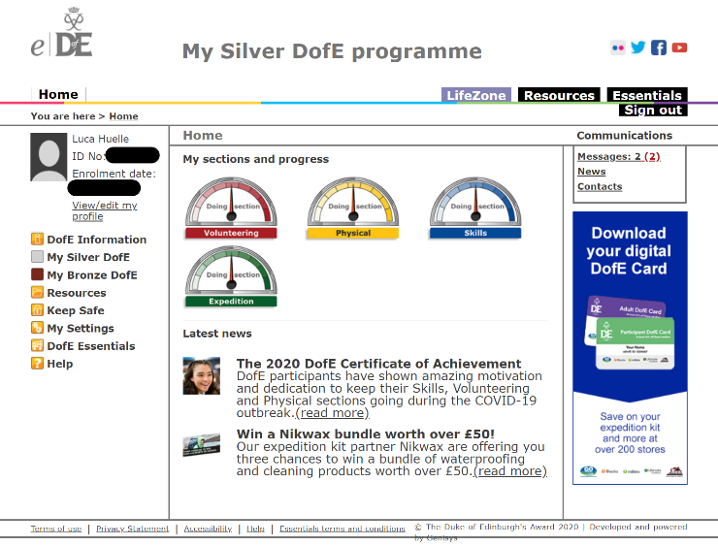

## Screenshot eDofE section overview

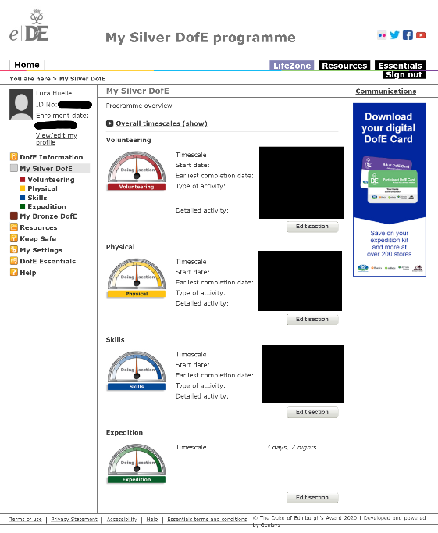

## Screenshot Example of completed section information in eDofE

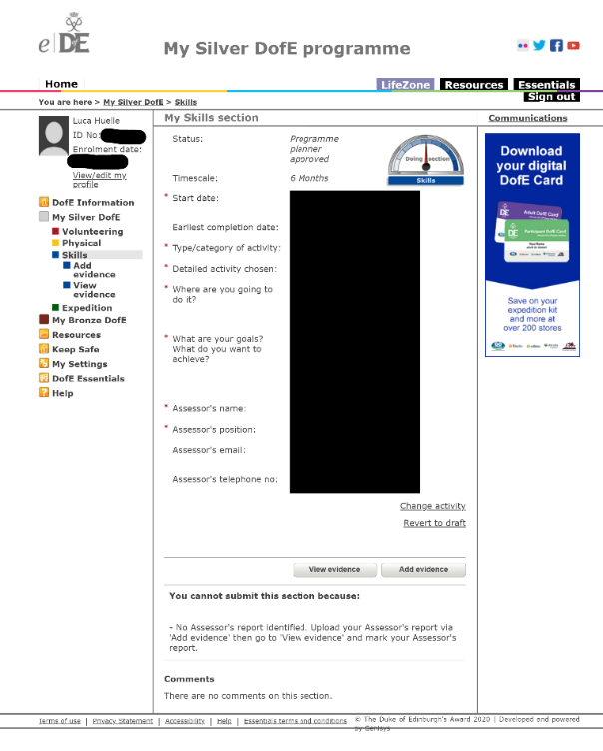

## Screenshot Example Google Calendar week view

Source: [https://miro.medium.com/max/3920/1*MVePFPo19hol8zrINy5K0w.png](https://miro.medium.com/max/3920/1*MVePFPo19hol8zrINy5K0w.png)

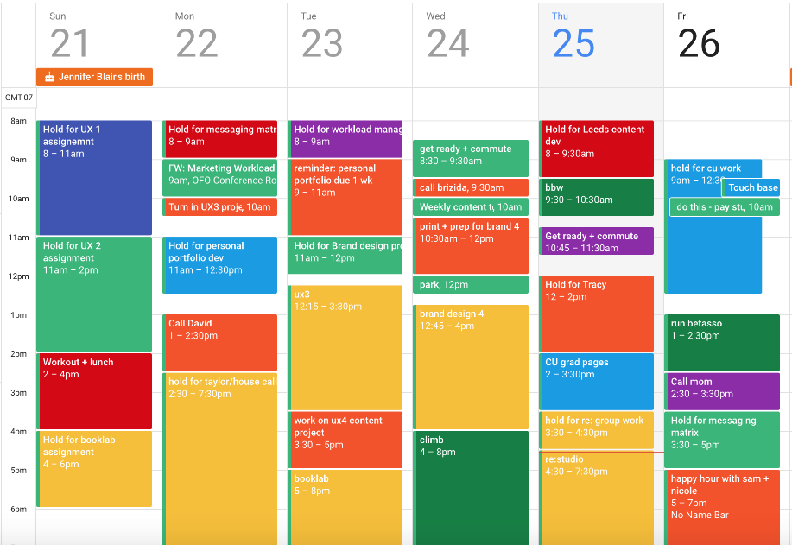

## Screenshot Adding an event to Google Calendar

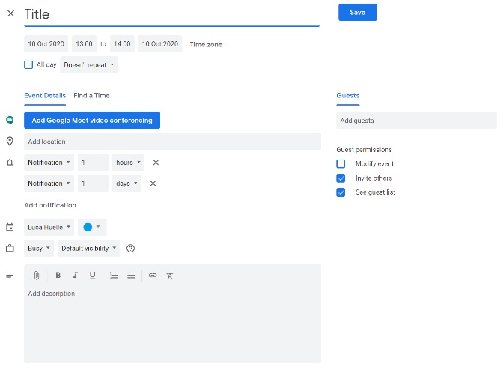

## Screenshot Student grade overview in Google Classroom

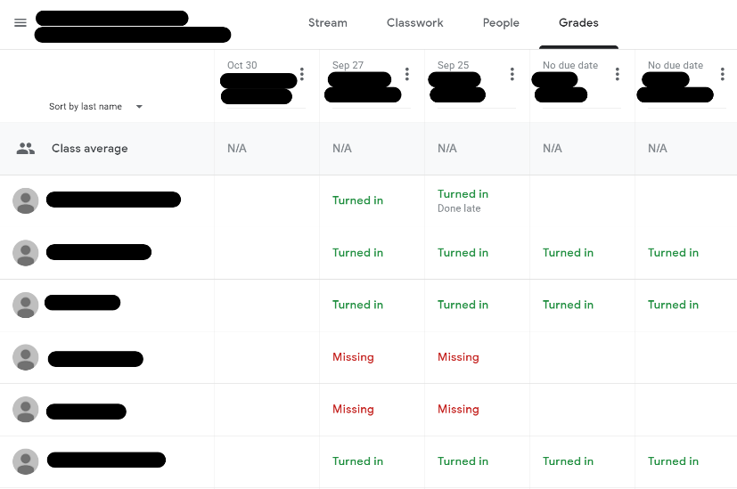

# Appendix C – Diagram and notation keys

## Data flow diagrams

External Entity

Process

Data store

Data flow